

Task 0: Get Movin’!

# Overview

Ever wanted to just figure out how easy it is to get a motor moving? Let’s find out...

# Objectives

The goal of this task is to get the motors to spin using a breadboard, a switch, and a battery pack!

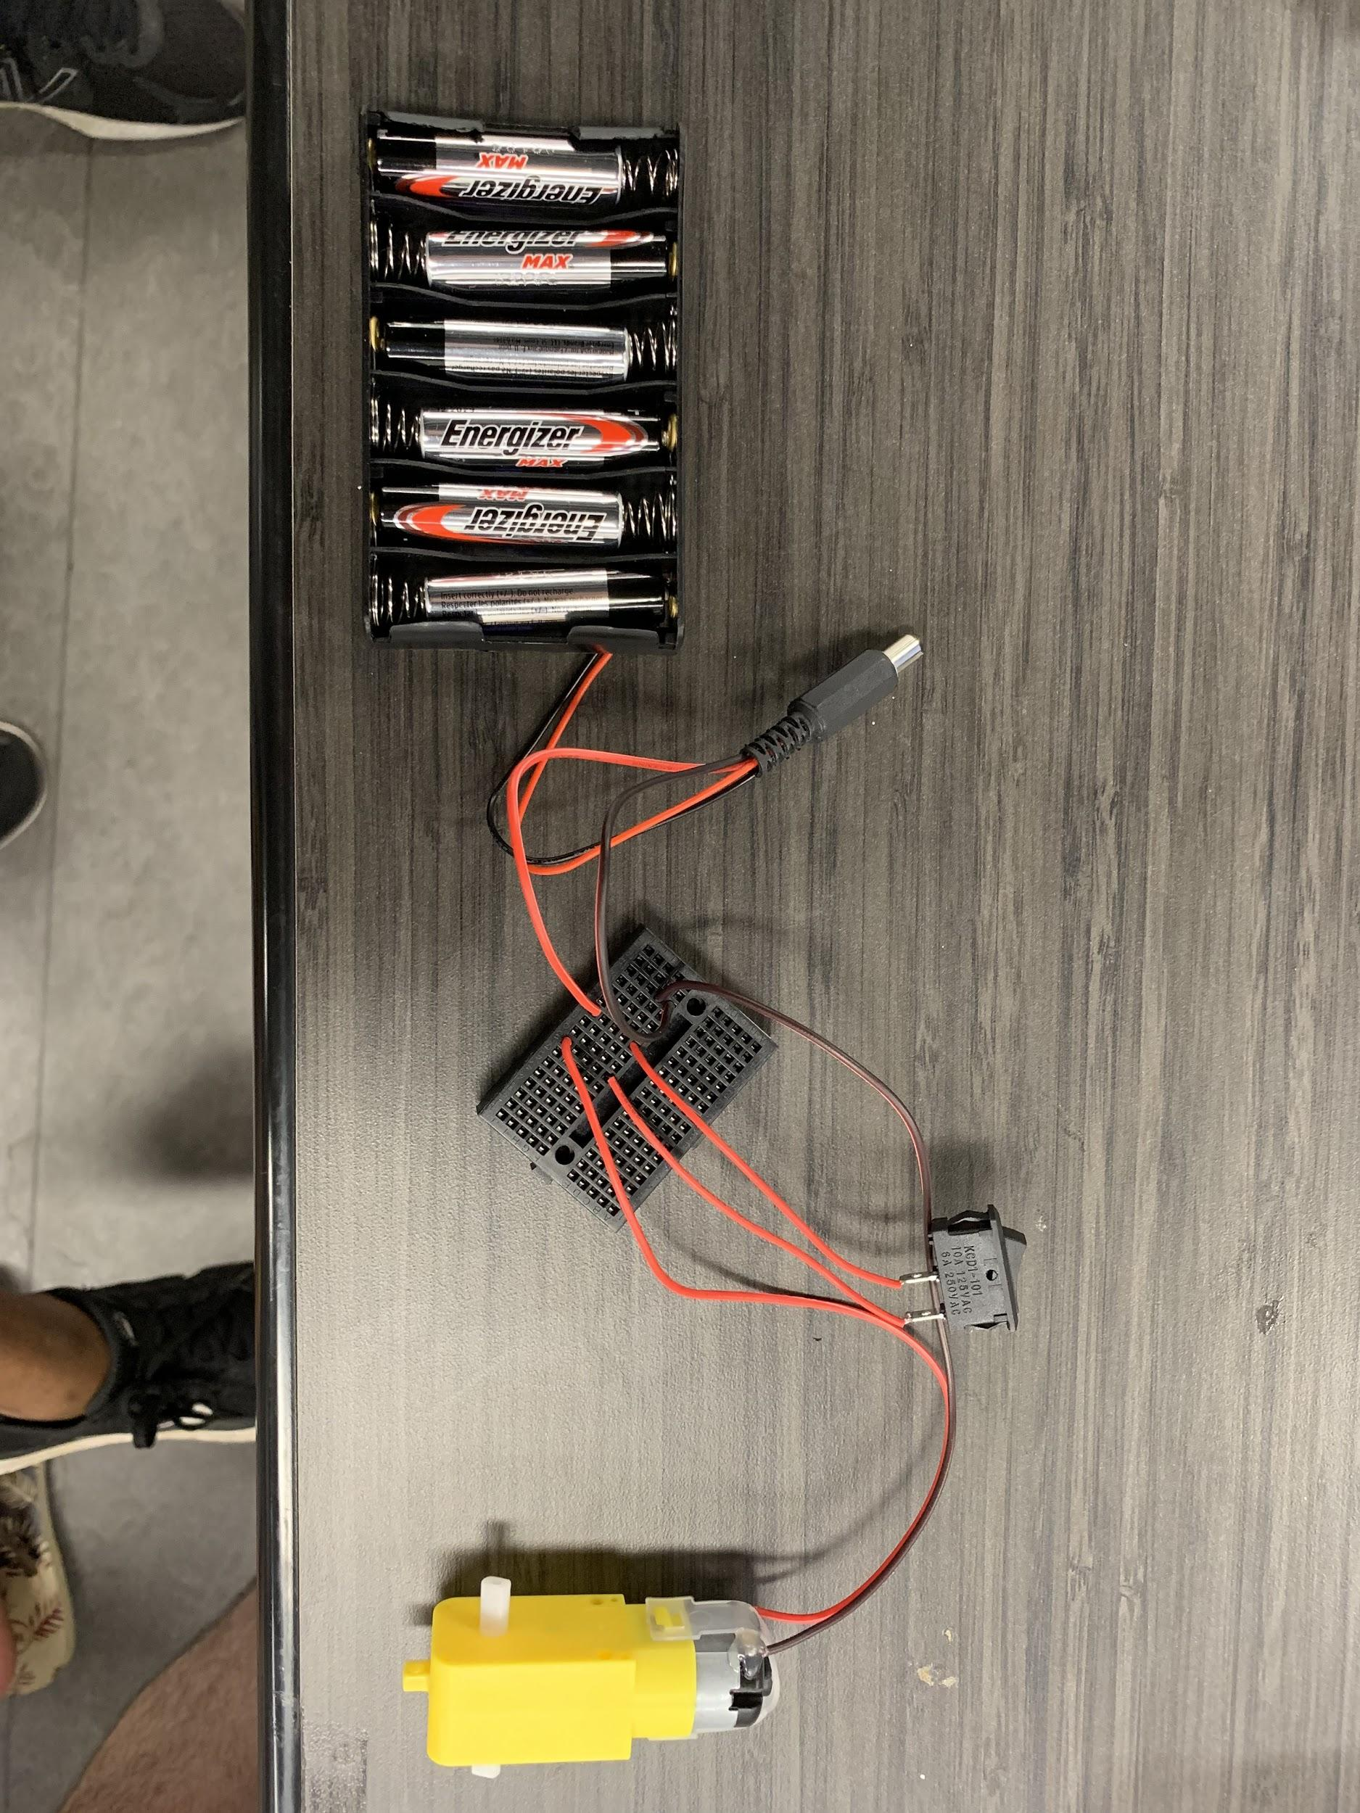

# Materials Needed

1. **breadboard**
2. **a switch**
3. **motor**
4. **battery pack**

**Please note: 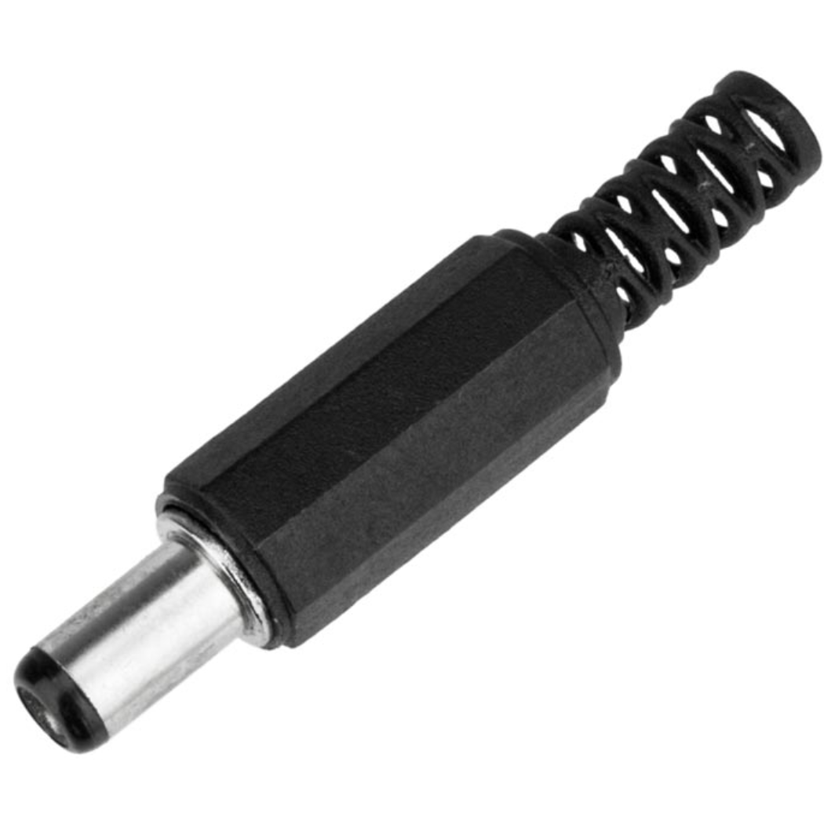 is a barrel jack!**

# Instructions

1. Place all 6 batteries into the battery pack
2. Connect the black wire from barrel jack to a breadboard cell
3. Connect to a red wire from barrel jack to a breadboard cell not in the same row
4. Connect switch’s one end to same row as red wire from barrel jack. Connect the other end to a different row (not the same as any of the other rows from before!)
5. Place motor’s red wire to that row from step 4 and the black (GND) wire to the row from step 2.
6. Now turn on the switch!

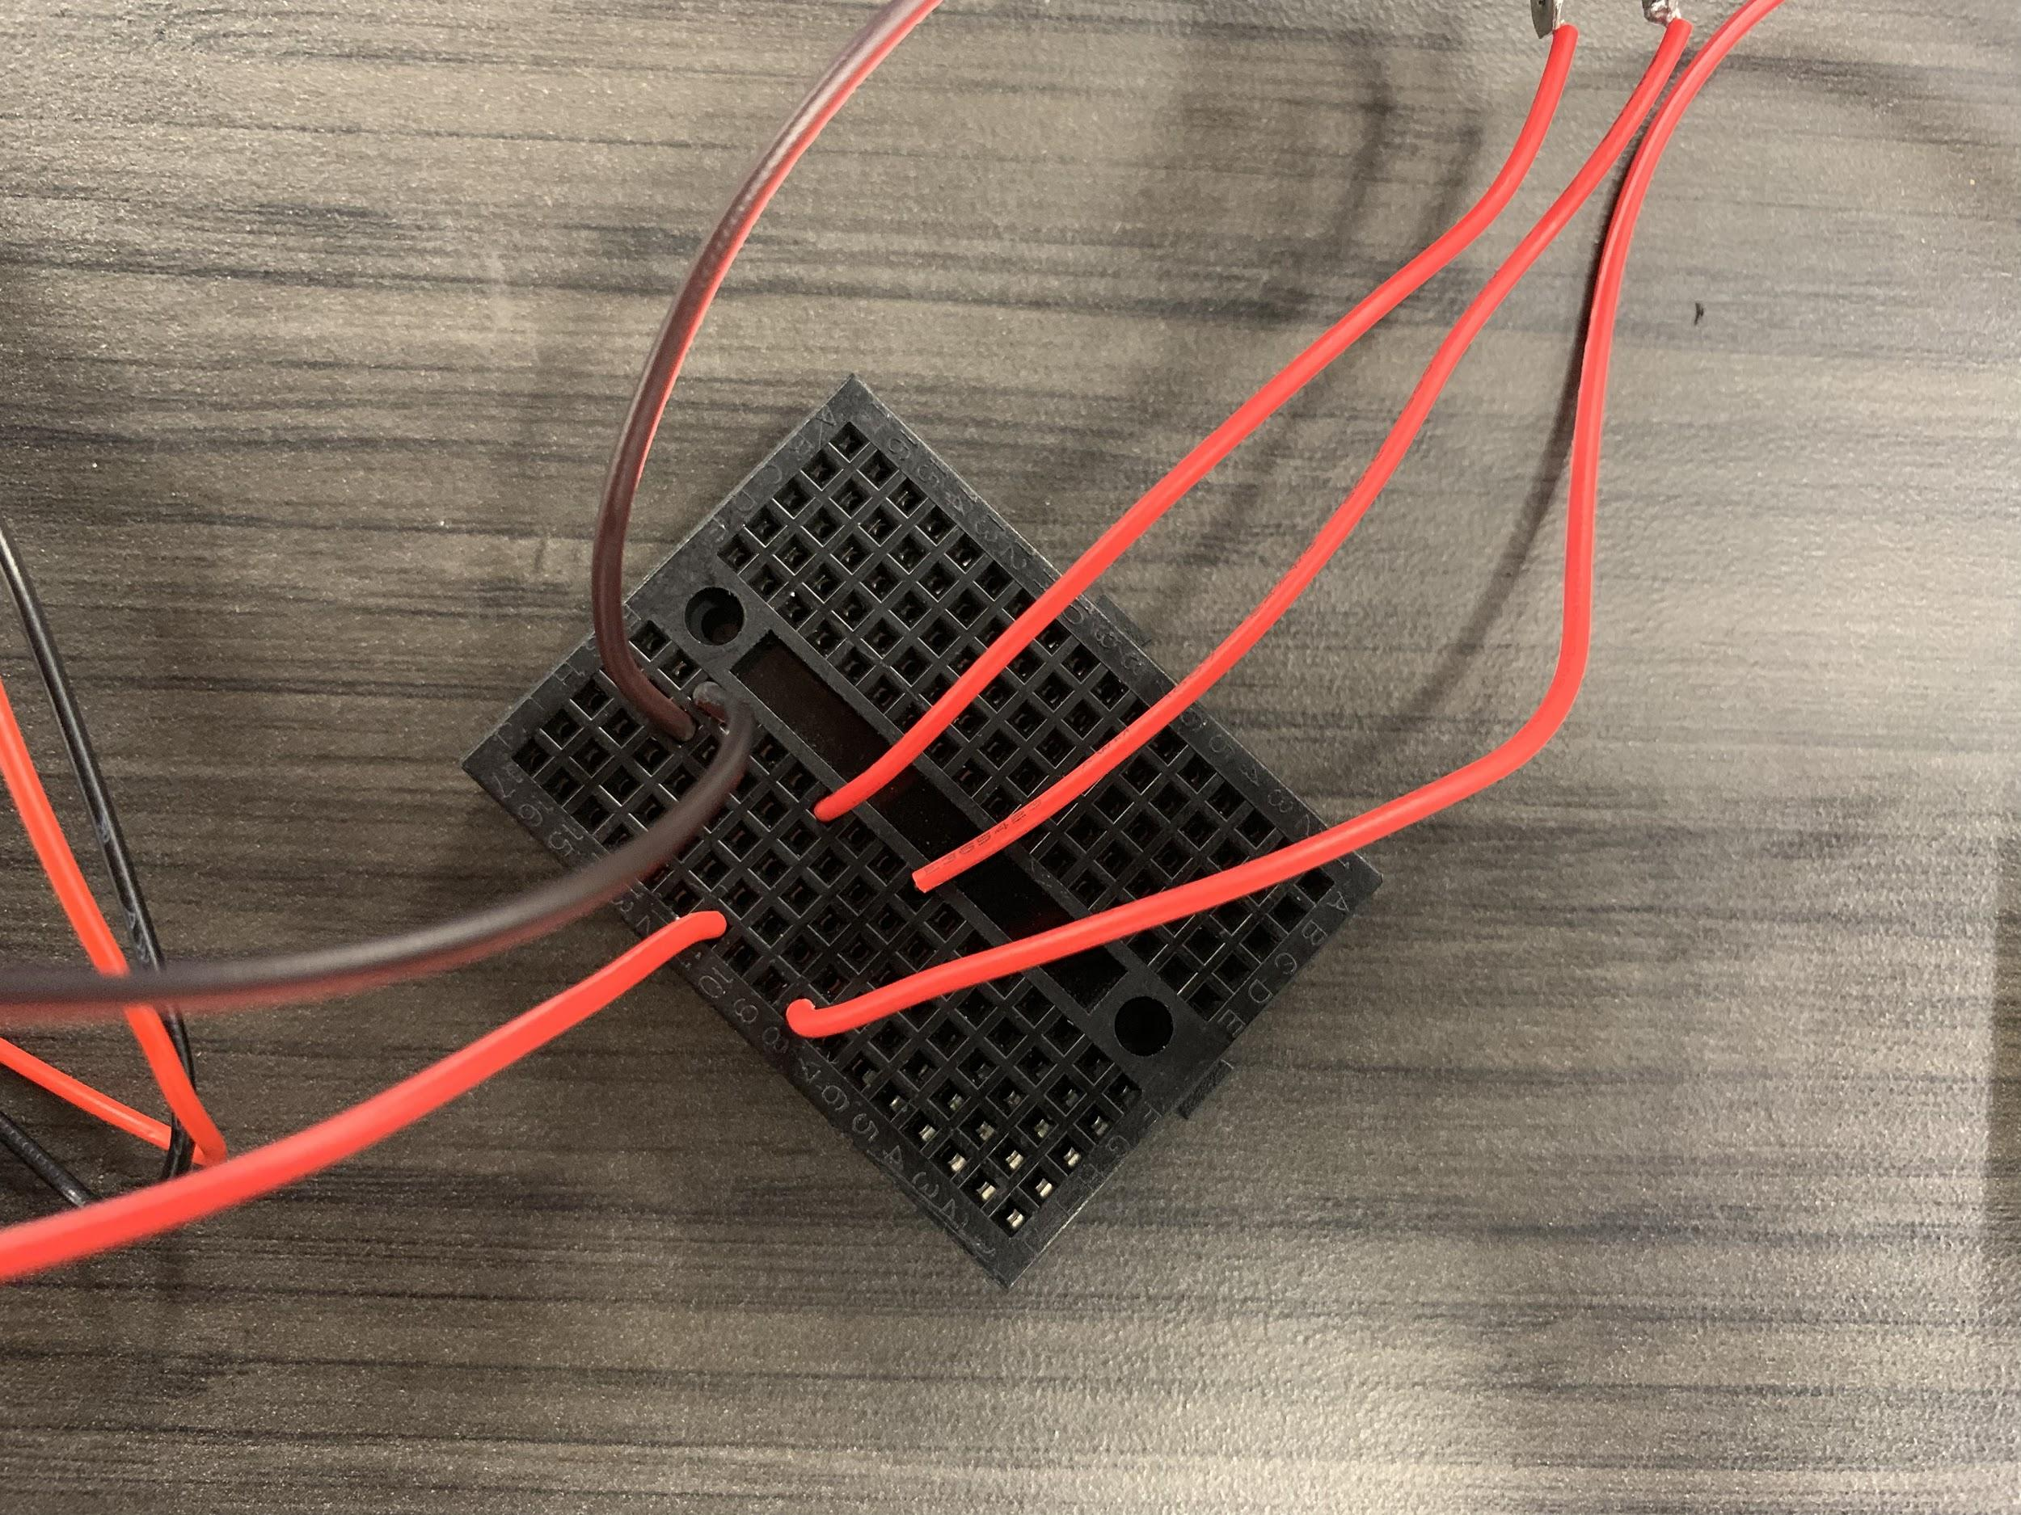





Task One: Construction

# Overview

We’re going to lay the ground work here by starting the car’s body construction. Credit to Stephen A. Edwards’s guide on constructing the chassis for the car!

# Objectives

The goal of this task is to have the car parts together and constructed. Instructions start on the next page! This part of the tutorial has been derived from a different tutorial, so edits and changes have been made! Please be aware!

# 

**Next page..! →**

# 

# 

*Please ignore the switch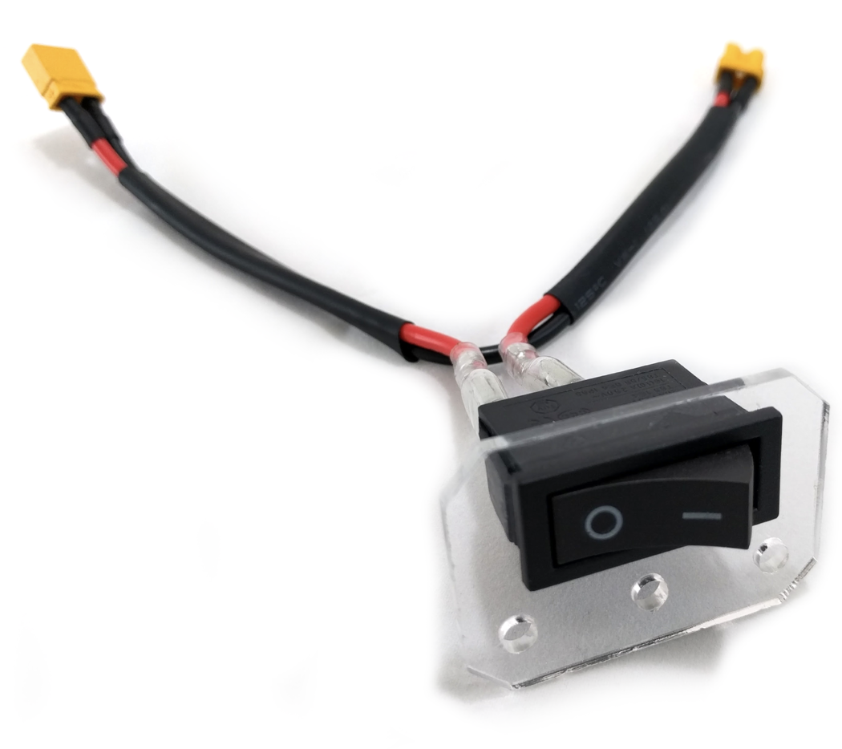 in the upcoming picture diagrams

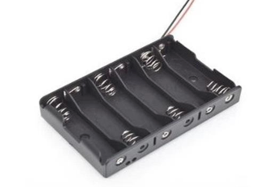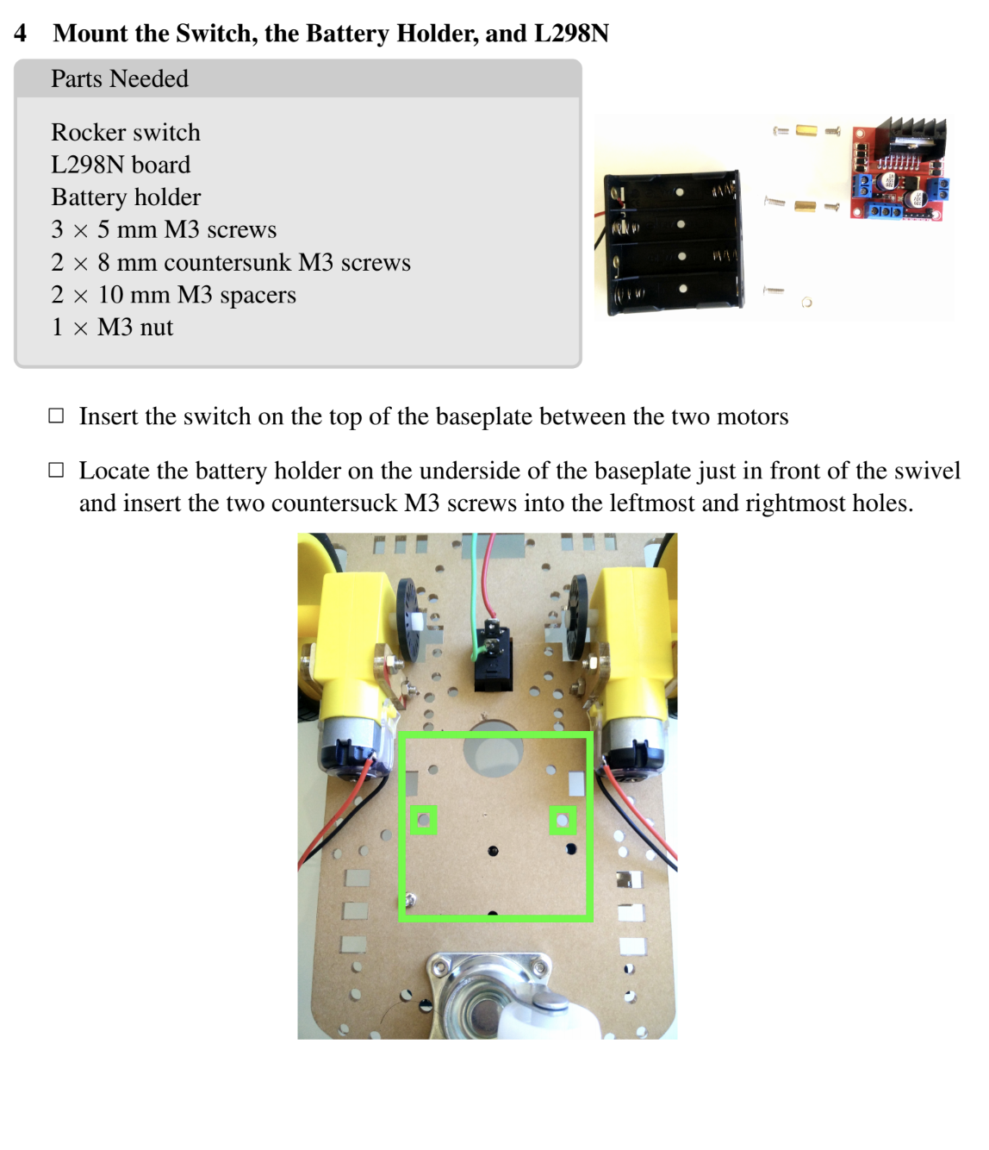

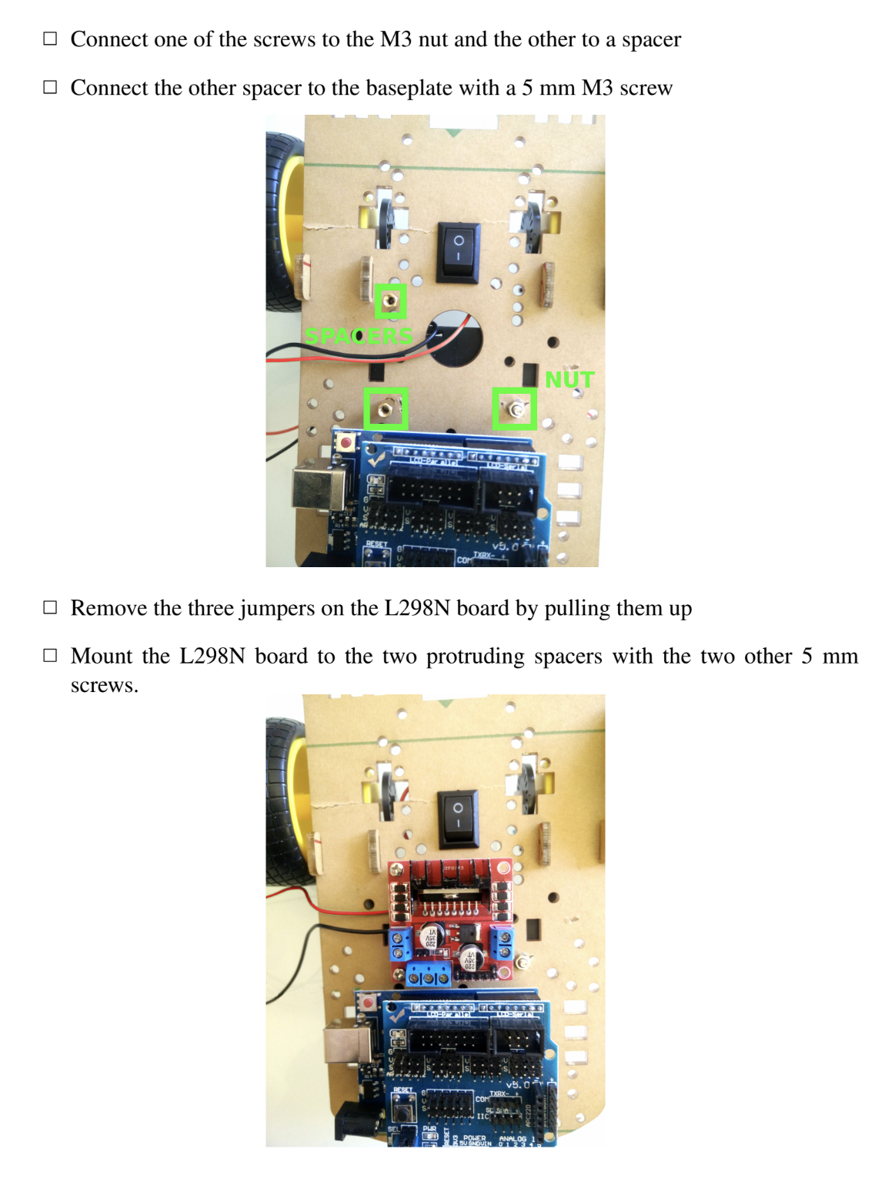

Lastly, fill up your battery cell with 6 double AA batteries and plant it on top of the chassis behind the red motor driver!





Task Two: Moving Forwards and Back

# Overview & Purpose

Let’s finally get this car moving! We’re going to be using the H-bridge 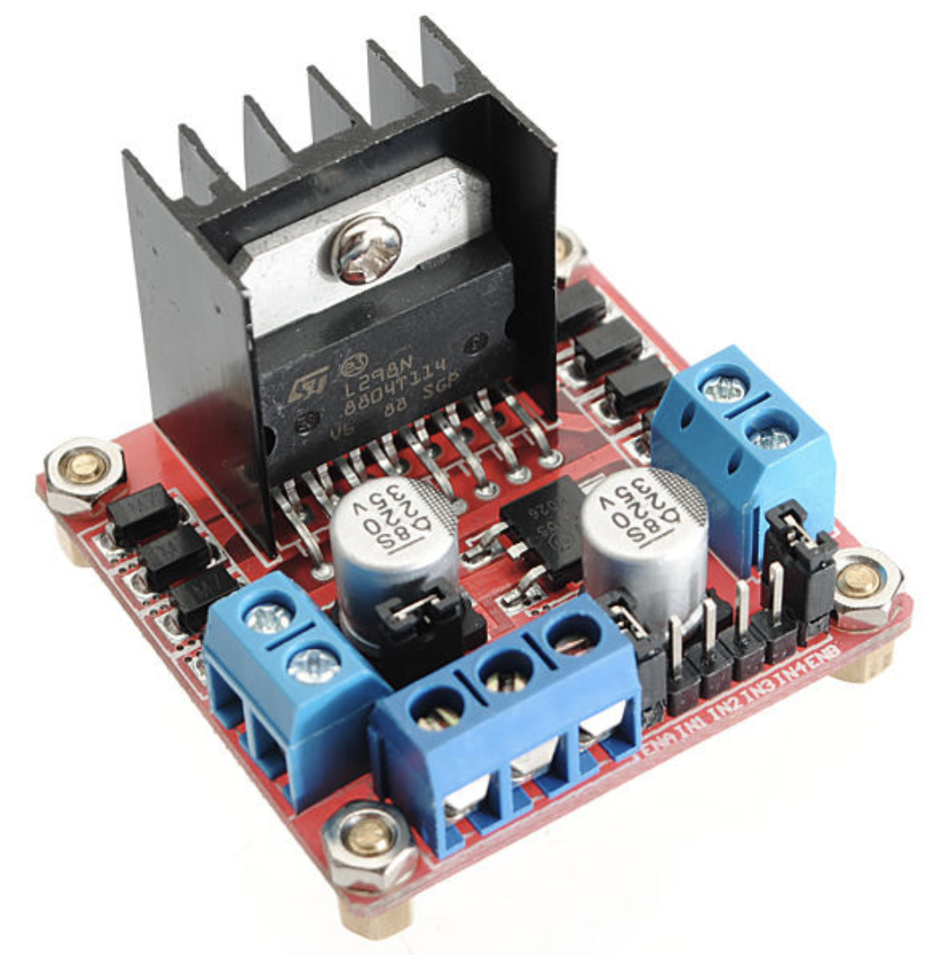 (L298H) to get the car to move forwards and backwards using some pre-made code.

# Objectives

1. Move car forwards
2. Move car backwards

# Materials Needed

1. Computer
2. Wires

# Instructions

1. Install the Arduino IDE from <https://www.arduino.cc/en/Main/Software>

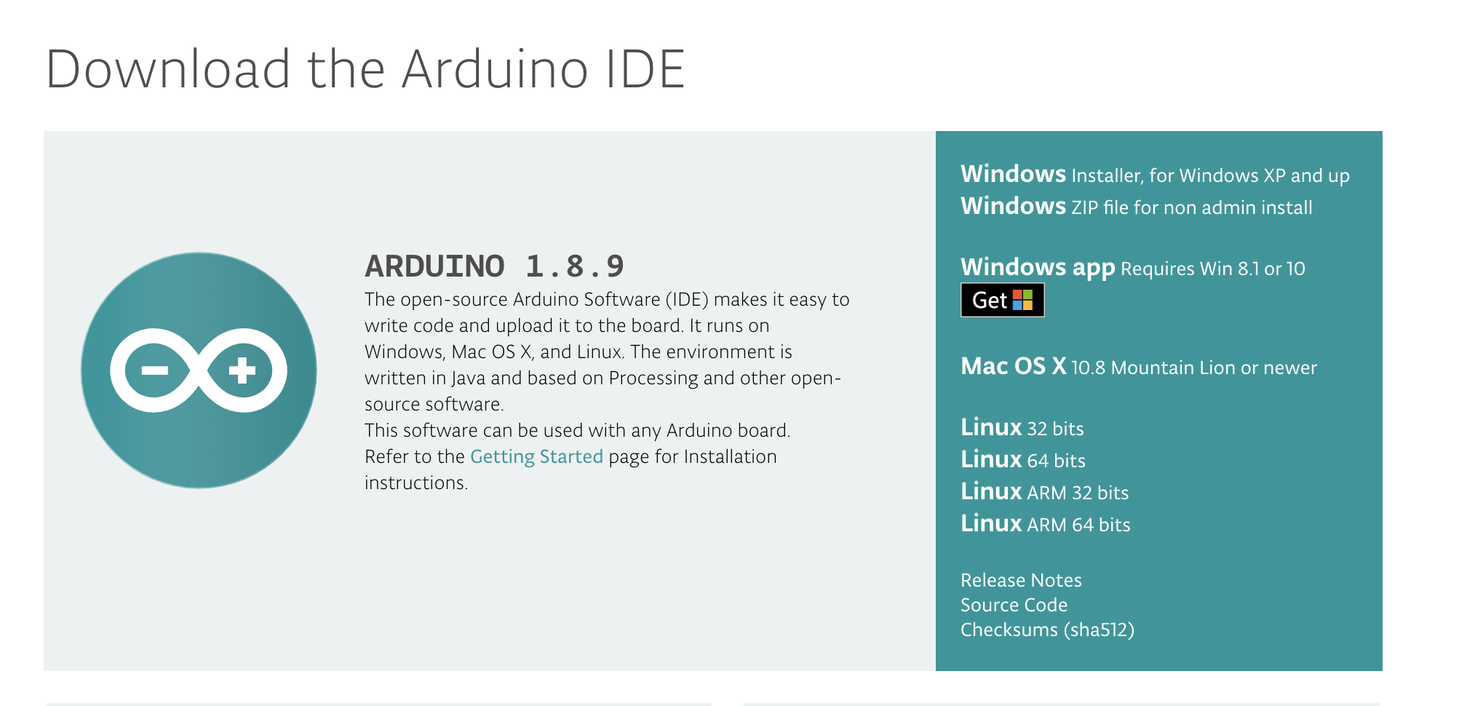

2. Navigate to <https://github.com/jedouard98/robotic-car-workshop>

3. Download the repository by clicking on this button here:

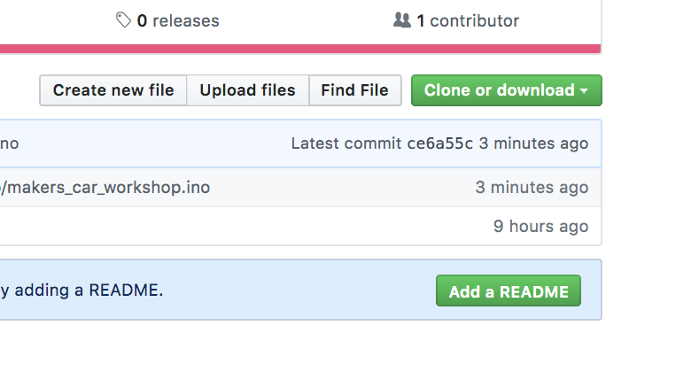

4. Open the Arduino IDE that you just downloaded. Now click open and open the file “makers_car_workshop.ino” that is inside makers_car_workshop folder (which is inside of the folder you just downloaded from github!)

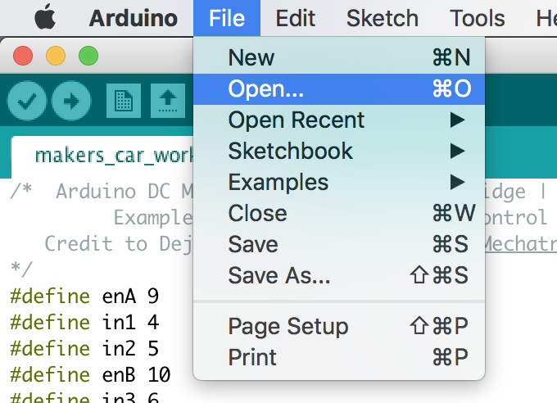

5. Now it’s time to flash the Arduino with the code you’re looking at. Connect the black wire to the arduino and to your computer. Click on tools and make sure that Board is the correct board (Arduino Uno) and that a port is selected that’s NOT any of these:

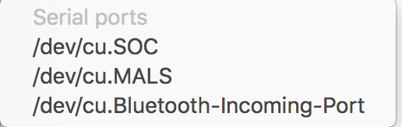

6. Lastly, to get the code onto the Arduino, all you have to do is click the leftward arrow button. It should flash to your Arduino with no problem!

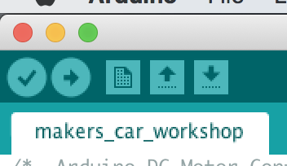

7. Now that the software’s done, let’s wire up the Arduino to the l298n (red module) and the motor. Follow this diagram/chart when wiring up your car to the motor driver:

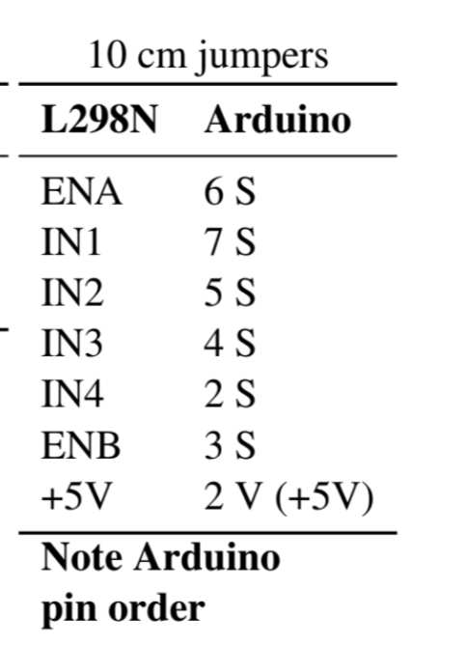

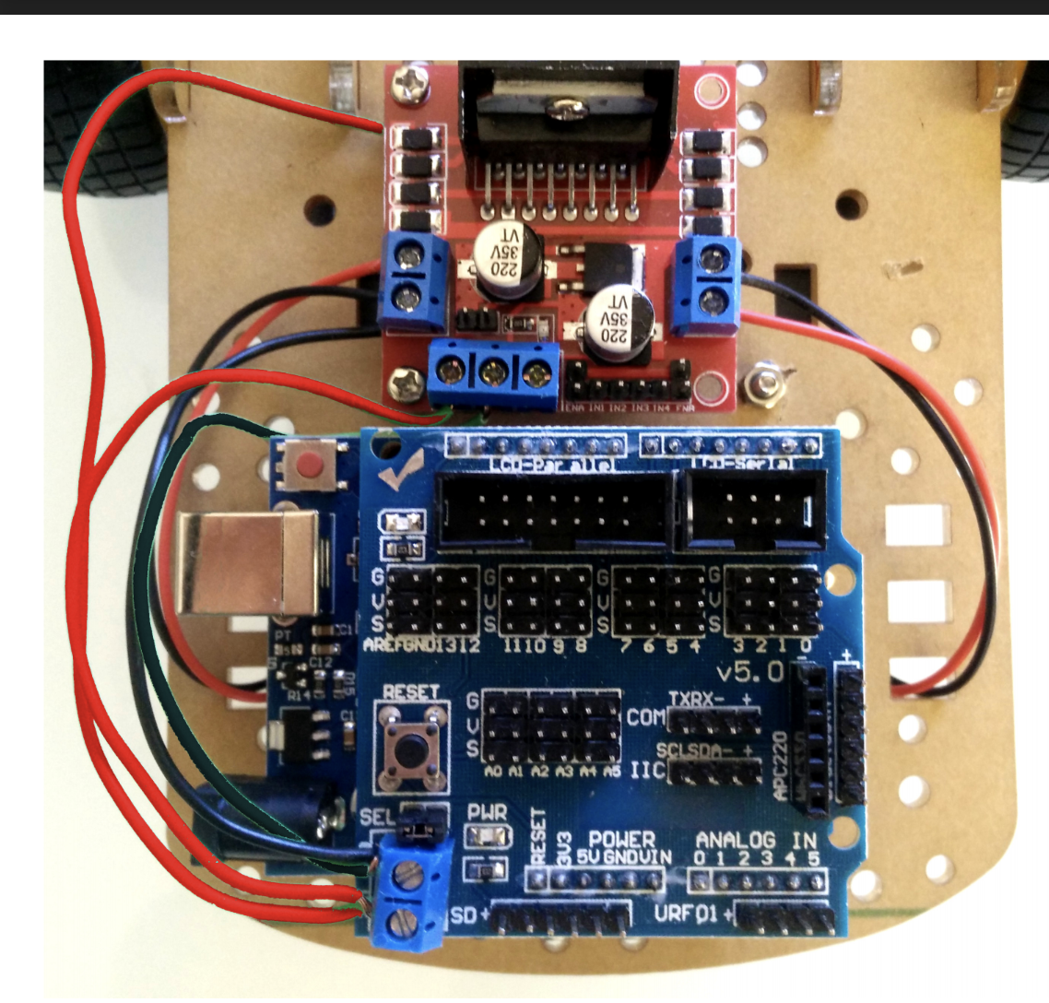

Place the barrel jack into your Arduino and put the red and black loose wires off the barrel jack into the motor driver’s GND and 12V pins, shown below

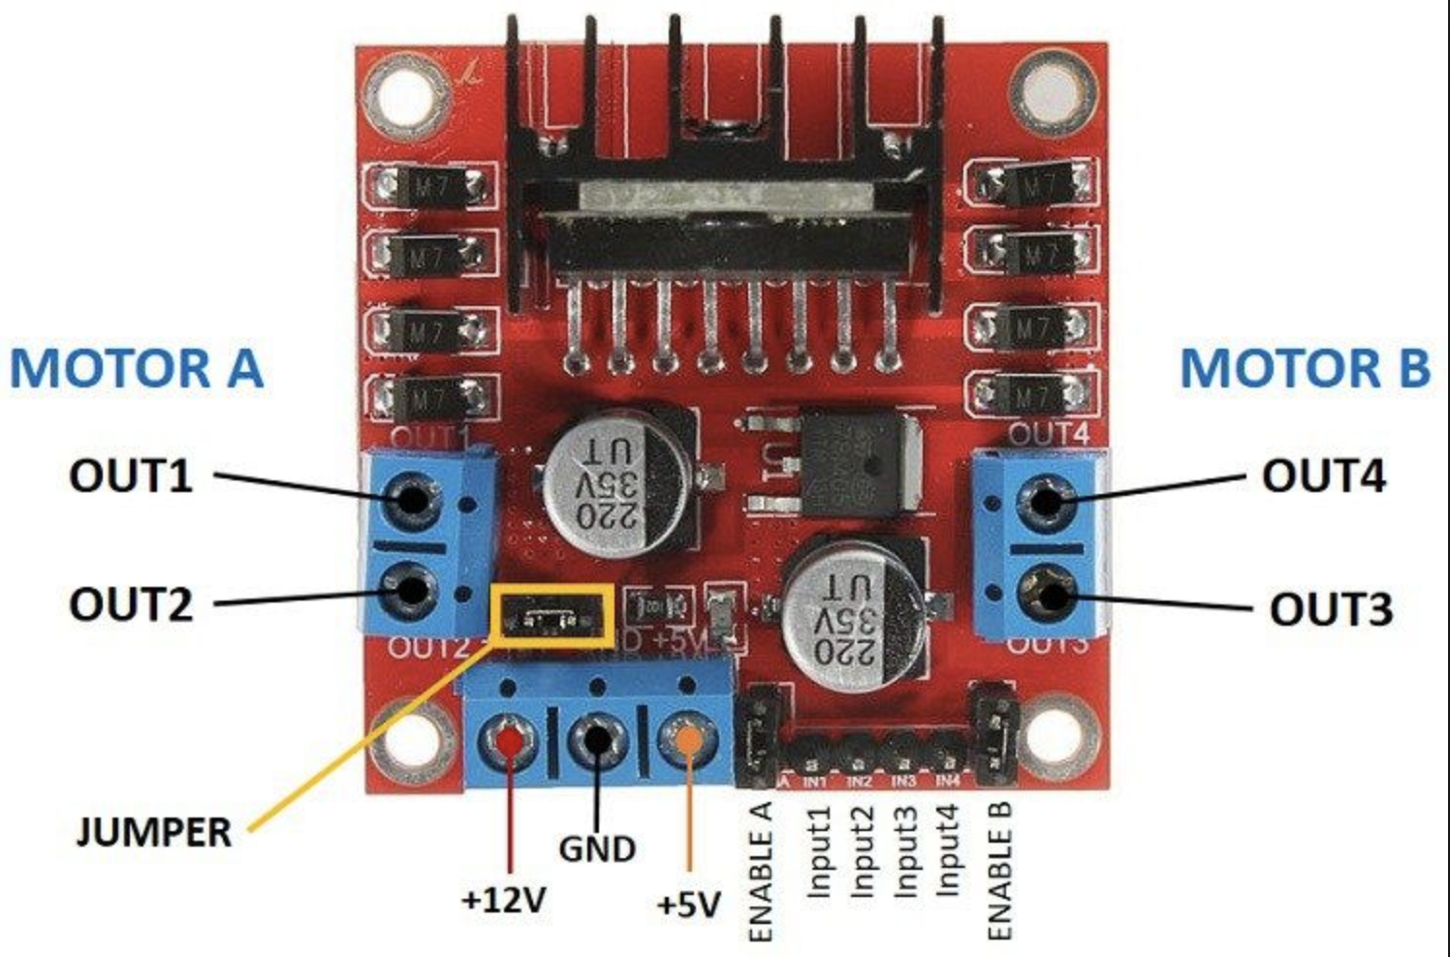

**The way you put wires in the L298N module is you unscrew the top and stick wires in the opening in the side. Then you screw the top down again and make sure it’s tight!

If you’ve done this correctly the car should move forwards and backgrounds.





Task 3: Turning the Car!

# Overview & Purpose

Now that you successfully flashed a file onto the car that can make the car go forwards and backwards, let’s try making the car turn

# Objectives

Get the car to turn left and right.

# Materials Needed

None! Just working on code

# Activity

To get the car to turn, it’s as simple as making one motor move slower than the other motor. What direction does the car turn when you move the left motor but not the right? What direction does the car turn when you move the right motor?

**IN1 and IN2 AND ENA are pins that correspond to 1 motor.

IN3 and IN4 AND ENB are pins that correspond to the 2 motor.